Harry Gwala District Municipality

MFMA s71 report for the period ending 31 January 2023.

10/2/2023

Budget & Treasury Office

**S71 MONTHLY REPORT**

Table of Contents

**1.1** **PURPOSE** 3

1.2 EXECUTIVE SUMMARY 3

**DELIBERATION** 4

1.3 Resolutions 5

1.4 Monthly Budget Statement Tables 5

2.1 Debtors Analysis 19

2.2 Creditors Analysis 24

2.3 Investment Portfolio Analysis 25

2.4 Allocation and Grant receipts and Expenditure 27

2.5 Councillor and Staff Benefits 28

2.6 Material Variances to the SDBIP 29

2.7 Municipal Manager’s Quality’s Certificate 40

**Glossary**

**Adjustments budget –** Prescribed in section 28 of the MFMA. The formal means by which a municipality may revise its annual budget during the year.

**AFS** – Annual Financial Statements

**Budget –** The financial plan of the Municipality.

**Capital expenditure -** Spending on assets such as infrastructure, land & buildings minor assets etc. Any capital expenditure must be reflected as an asset on the Municipality’s statement of financial position.

**DORA –** Division of Revenue Act. Annual legislation that shows the total allocations made by national to provincial and local government.

**Equitable share –** An unconditional grant paid to municipalities. It is predominantly

targeted towards funding the Indigent Policy.

**FMG** – Financial Management Grant.

**GRAP –** Generally Recognised Accounting Practice. The standard for municipal

accounting.

**IDP –** Integrated Development Plan. The main strategic planning document of the

Municipality.

**MBRR –** Local Government: Municipal Finance Management Act (56/2003): Municipal budget and reporting regulations.

**MFMA –** Local Government: Municipal Finance Management Act (56/2003). The principle legislation relating to municipal financial management.

**MIG** – Municipal Infrastructure Grant.

**MTREF –** Medium Term Revenue and Expenditure Framework (MTREF). The medium term financial plan, usually 3 years, based on a fixed first year and indicative further two years budget allocations. Also includes financial information of the previous and current year.

**Operating expenditure –** Spending on the day to day expenses of the Municipality such as salaries and wages, repairs and maintenance etc.

**SDBIP –** Service Delivery and Budget Implementation Plan (SDBIP). A detailed plan

comprising annual and quarterly performance information. Harry Gwala District Municipality MFMA s71 Monthly Report Page 5

**Strategic objectives –** The main priorities of the Municipality as set out in the IDP.

Budgeted spending must contribute towards the achievement of the strategic objectives.

**Vote –** one of the main segments into which a budget of a municipality is divided for the appropriation of money for the different departments or functional areas of

the municipality; and which specifies the total amount that is appropriated for the purposes of the department or functional area concerned. .

**YTD –** Year to date

**YoY –** Year on Year

**DBSA** – Development Bank of South Africa

**REPORT ON S71 OF THE MFMA FOR THE PERIOD ENDING 31 JANUARY 2023**

* 1. **PURPOSE**

To table a report on the Implementation of the current budget and the financial state of the Municipality in terms of Section 71 of the Municipal Finance Management Act (MFMA)

**LEGAL FRAMEWORK**

* Local Government: Municipal Finance Management Act, 56 of 2003
* SCM Regulations
* SCM Policy
* Municipal Budget Reporting Regulation
* Division of Revenue Act

## 1.2 EXECUTIVE SUMMARY OR BACKGROUND

**Legislative Requirements**

In terms of the section 71 of the MFMA the accounting officer of a municipality must by no later than 10 working days after the end of each month submit to the Mayor of the municipality and the relevant provincial treasury a statement in the prescribed format on the state of the municipality’s budget reflecting the following particulars for that month and for the financial year up to the end of that month:

*(a)* Actual revenue, per revenue source;

*(b)* actual borrowings;

*(c)* actual expenditure, per vote;

*(d)* actual capital expenditure, per vote;

*(e)* the amount of any allocations received;

*(f)* actual expenditure on those allocations, excluding expenditure on—

(i) its share of the local government equitable share; and

(ii) allocations exempted by the annual Division of Revenue Act from compliance with this paragraph; and

*(g)* when necessary, an explanation of—

(i) any material variances from the municipality’s projected revenue by source, and from the municipality’s expenditure projections per vote;

(ii) any material variances from the service delivery and budget implementation plan; and

(iii) any remedial or corrective steps taken or to be taken to ensure that projected revenue and expenditure remain within the municipality’s

**DELIBERATION/DISCUSSION**

The discussion that follows, in terms of MFMA Section 71 above, intends to inform the Budget and Treasury Committee on the progress made thus far in terms of implementing the 2022/2023 budget for the period ending 31 January 2023.

## RESOLUTIONS

This report will be tabled to Executive committee and therefore the resolution will be available once it tabled to council in terms of Sec 52 (d) of the MFMA.

## Monthly Budget Statement Tables

**Monthly Budget Statements Summary**

Table C1 below provides a summary of the overall performance in the Municipality and is unpacked in the sections that follow.



**Financial Performance**

Table C2 provides the statement of financial performance by standard classification.



This table assess the revenue by department and then the expenditure for the period ending 31 January 2023. Revenue receipts in January have largely constituted of service charges which is water and sanitation. The overall budgeted revenue cash receipt for the month of January is 18%.

Expenditure by standard classification presents the expenditures by the departments. Water Services Department has largest expenditure by 4% in the period ending 31 January 2023. This being largely attributable to the backlog demand of operations and maintenance of water schemes in the District.

Table C3 presents the same information as the table above, the difference being that it’s by Municipal vote.



**Statement of financial Performance**

This schedule provides information on the planned revenue and operational expenditures against the actual results for the period ending 31 January 2023.



**Capital Expenditure**

Table C5 below reports on the capital expenditures by departments (municipal vote) and also by standard classification. The bottom part of the schedule looks at the funding sources of the capital projects.



As alluded to above, the capital expenditure programme for the month ending 31 January was R119, 9m of capital expenditure against year to date budget.

The chart below presents a high level analysis of YTD capital expenditure budget against the YTD actual expenditure.

**Chart 1: 2022/2023 CAPEX YTD BUDGET & YTD ACTUAL**

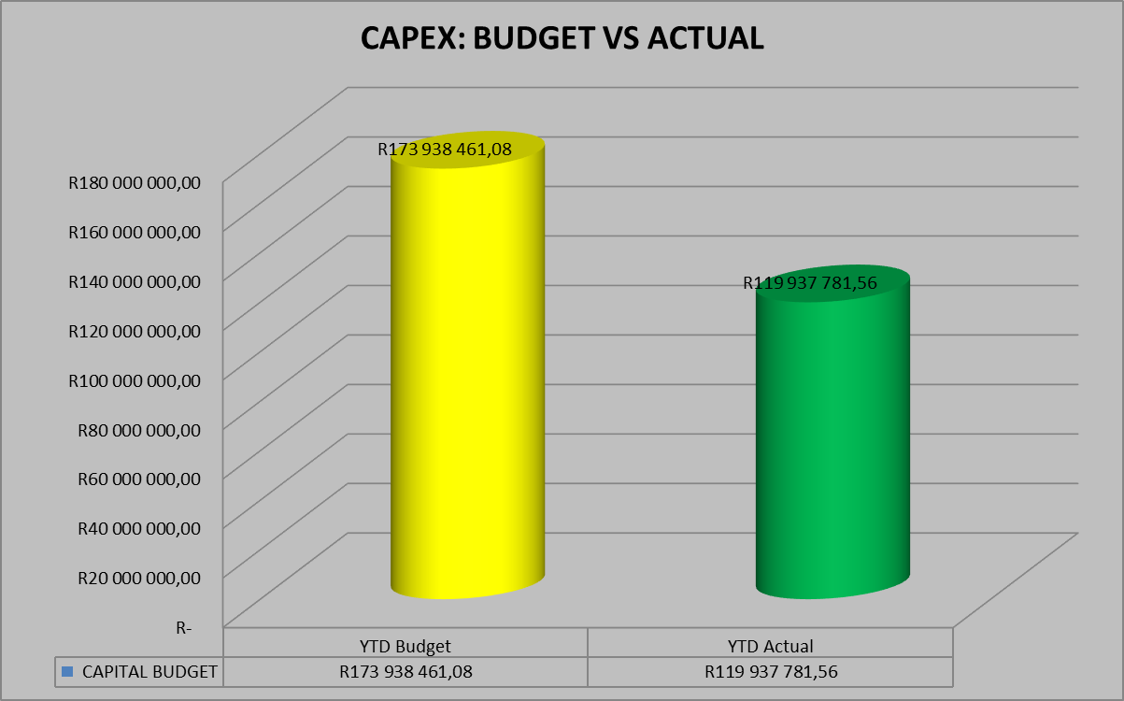

As at 31 January 2023, the year to date actual expenditure was R119, 9million against a YTD budget of R173, 9million. In monetary terms, these figures represent 69 per cent performance against the capital development programme as at 31 January 2023.

Table C6 displays the financial position of the municipality as at 31 January 2023.



Table C7 below display the Cash Flow Statement for the period ending 31 January 2023.



**PART 2 – SUPPORTING DOCUMENTATION**

## Debtors Analysis

The table presented below summarises the Debtors Age Analysis as at 31 January 2023.

**Table 2.1.1: Debtors Age Analysis by Income Source**



The municipal consumer debt is currently increasing citing rigorous actions to ensure that this trend is prevented from continuing as it has a direct negative impact on municipal cash flows.

**Chart 2: Debtors Age Analysis by Customer Group**

The information presented in the chart above ranks total debt owed to the municipality from highest to the lowest,

* Households 84%
* Government 10%
* Business 6%

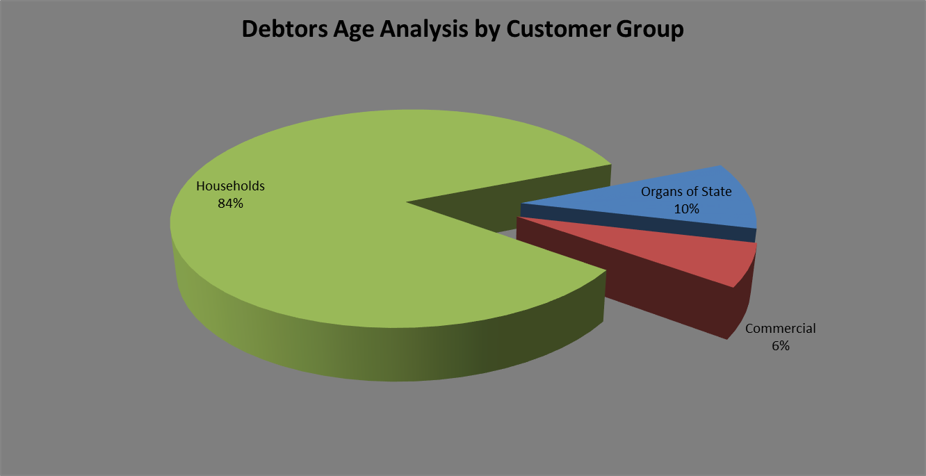

The chart above shows that for each debtor type the amounts owing to the municipality have increased on a year to year basis.

The table that follows below unpacks the revenue receipts per Local Municipality in the District

**REVENUE RECEIPTS**

**Revenue receipts per Area**



The table above presents the cash receipts from consumer debtors in each of the detailed areas as well as the comparative receipts for the previous month. The total cash collected for January 2023 is R3, 8million. The collection for prepaid in the month of January is R 805 469. Total cash collected including prepaid for the month ending 31 January is R 4,632,733.

**BILLING VS COLLECTION TREND FOR JANUARY 2023**

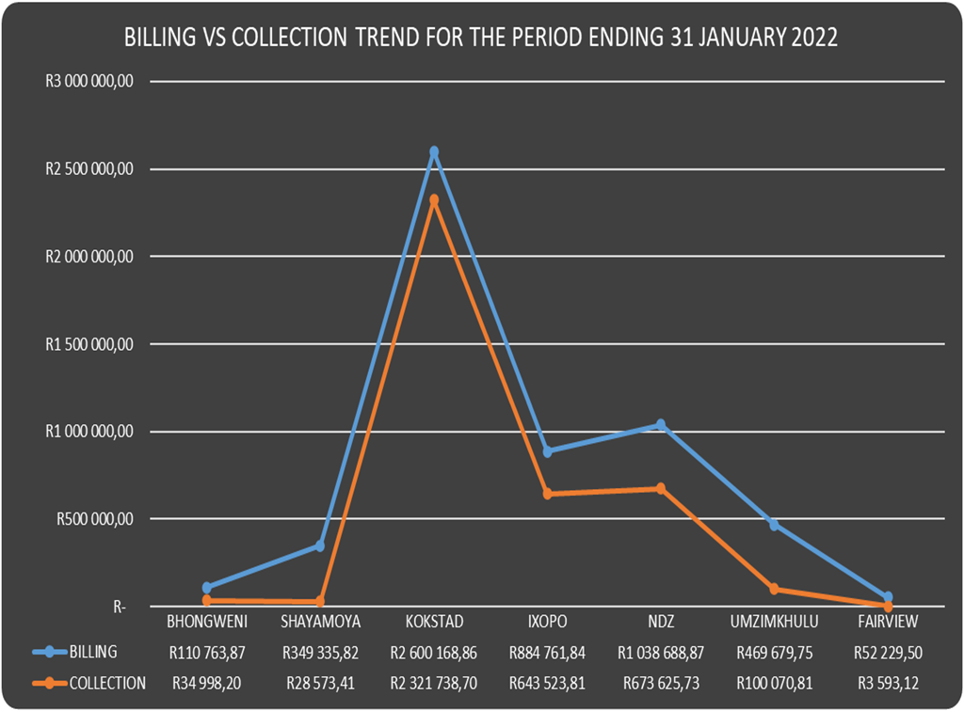

**BILLING VS COLLECTION**

The chart that follows below shows the comparison between billing and collection for the period ending 31 January 2023(Comparison between December 2022 and January 2023)

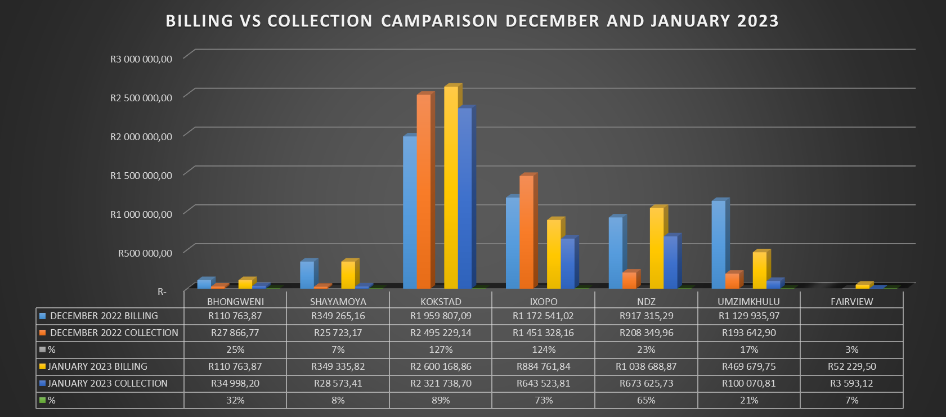

**Debtors age analysis per service**

The municipality’s total outstanding debtors amounted to R 227,423,990 as at 31 January 2023 compared with the R 224,558,756 as at 31 December 2022. Current debt represents 3% of the total outstanding debt compared with the 3% of December 2022; 30 days and older debt 2% compared with the 6% for December 2022; 60 days and older debt 5% compared with the 2% of October 2022; and 90 days 2% compared with the 2% of December 2022; 120 days to History and older 88% compared with the 87% for December 2022.

Current debt increased with R 2,865,234 to R 227,423,990 compared with the R 224,558,756 as at 31 January 2022; 30 days + debt Decreased with R 7,936,122; 60 days + increased with R 8,186,632; 90 days + debt decreased with R 615,259 and 120 + days and older debt as at 31 January 2023 has Increased with R 3,612,171 to R 199,245,649 compared with the R 195,633,478 as at 31 January 2023.

**Debtors age analysis per debtor type**

Business debtors owes the municipality R 13,940,068 (6%); Municipal debtors R 1,185,231 (0%); domestic debtors R 172,340,045 (76%); Government accounts R 21,173,094 (9%); Indigent debtors R 11,718,021 (5%); Deceased debtors R 1,453,248 (1%) and other debtors R 5,614,283 (2%) of the total outstanding debt of R 227,423,990.

## Creditors Analysis

Table SC presents the aged creditors as at 31 January 2023.



## Investment Portfolio Analysis

The following information presents the cash at bank and short term investments balances broken down per investment type as at 31 January 2023.

**Cash and Bank Balances (Investments)**



## Allocation and Grant receipts and Expenditure

Table SC 6 displays information relating to grant receipts.



It is clear from the chart above that the bulk of the grants received by the municipality are from the National Treasury.

Table SC7 track the expenditure on Conditional grant funding.



## Councillor and Staff Benefits

Table SC8 presents the expenditure of councillor and staff benefits at 31 January 2023.



## Material Variances to the SDBIP

The following section analyses material variances between the actual targets as at 31 January 2023 and the budget for the same period. This report analyses each major component under following headings;

* Revenue by Source
* Operational Expenditure by Type, and
* Capital Expenditure
* Financial Position
* Cash Flows

**REVENUE**

The chart displays a comparison between the 2022/23 financial year revenue budget and the performance against this budget as depicted in the form of Year to date (YTD) Actual figures. It should be emphasised that the information presented relates to “performance” rather than “cash movements” in terms of the revenue items listed below. This accounting principle relating to municipal performance is best illustrated in the analysis that follows.

**Chart 3: Revenue Analysis**

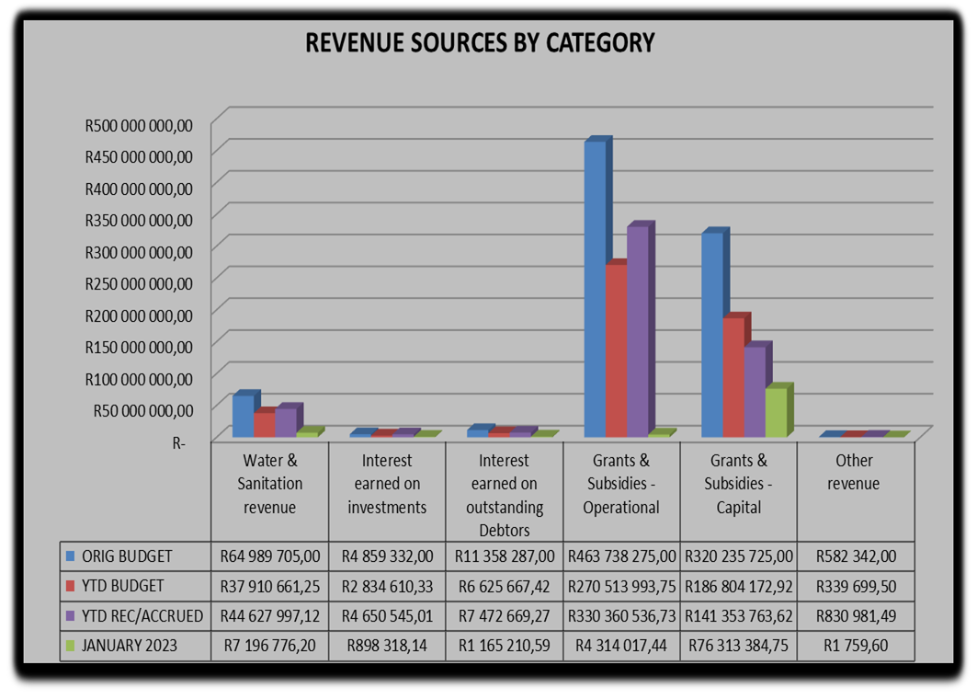

**Water & Sanitation Charges**

The year to date **actual** water & sanitation charges **(billing)** as at 31 January 2023 was R44, 6million against a year to date **budget** of R37, 9million.

**Interest Earned on External Investments**

The interest earned on external investments year to date actual is R4, 6million against year to budget of R2, 8million representing 164 per cent of the year to date budget.

**Transfers Recognised - Operational**

The operational grants revenue of R270, 5million against a year to date budget of R330, 3million is largely attributable to the YTD equitable share received.

**Transfers Recognised – Capital**

The total capital budget for the current year amounts to R320, 2m including vat. The YTD actual on capital amounts to R141, 3million, or 76% of the planned expenditure. Capital expenditure is mainly funded by means of National grants.

**Other Revenue**

The YTD performance of other revenue is R 830 981 against YTD budget of R 339 699.

**OPERATIONAL EXPENDITURE**

The chart below presents the YTD operational expenditure movements against the YTD budgets. An analysis of each expenditure line item category is discussed below.

**Chart 4: 2022/23 financial year Operational expenditure**

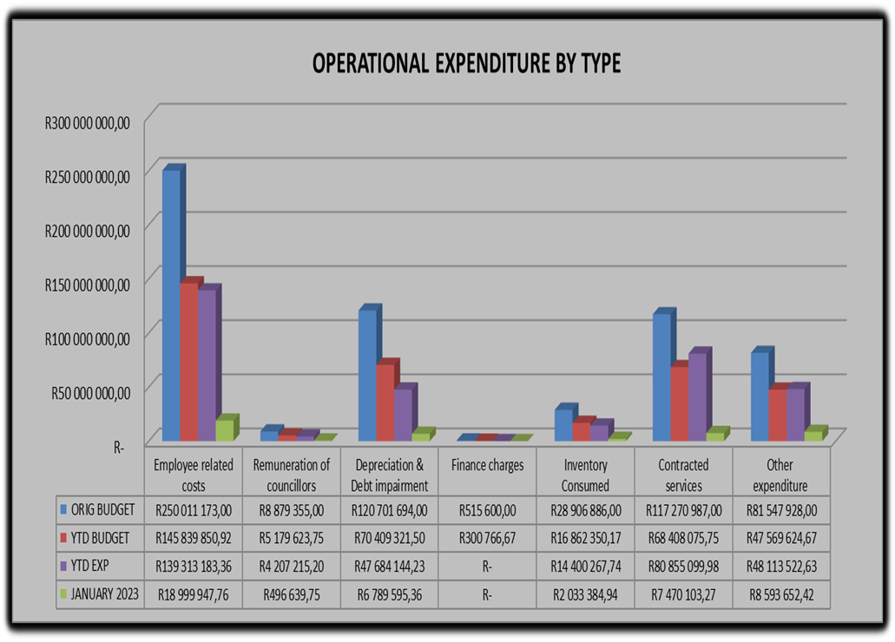

**Employee Related Costs**

The YTD budget for employee related costs is R145, 8million against a YTD actual of R139, 3million which is 96% of the YTD budget.

**Remuneration of Councillors**

The remuneration of councillor’s year to date expenditure is at R 4, 2million against a YTD budget of R5, 1million representing 81% of the year to date budget.

**Finance Charges**

No movement for finance charges in the period ending 31 January 2023.

**Inventory Consumed**

The inventory consumed has the original budget of R28, 9m. The year to date expenditure for inventory consumed is R14, 4m against a YTD budget of R16, 8million.

**Contracted Services**

The YTD budget for contracted services is R 80, 8milllion against a YTD expenditure of R 68, 4million and expenditure for the month of January 2023. The year to date expenditure is more than what was projected by 18 per cent for the month of ending January 2023.

**Other Expenditure**

The YTD budget for other expenditure was at R 48, 1milllion against a YTD expenditure of R 47, 5million and expenditure for the month of January 2023 is R 8, 5million.

**Performance assessment**

The Performance Assessment Report will be available on the second quarter of 2022/2023 financial year in terms of mid-term performance assessment in accordance with the Municipal Finance Management Act.

**Actual and revised targets for cash receipts**



**Capital Expenditure Trend**



**CAPITAL EXPENDITURE MONTHLY TREND**

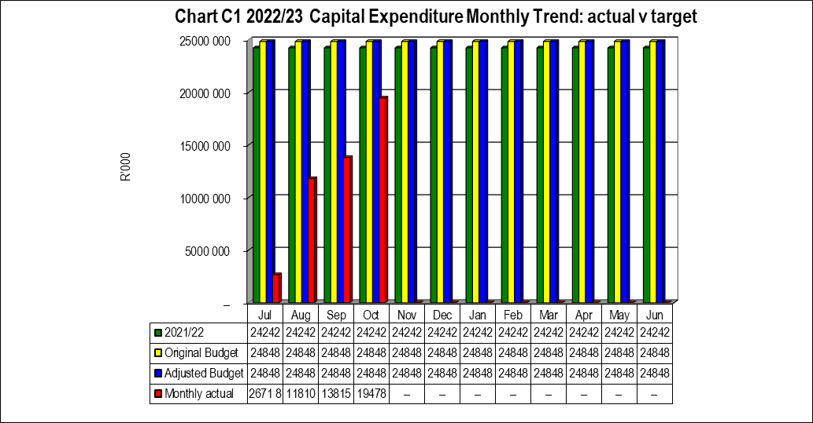

**Capital Expenditure on New Assets by Asset Class**



**Capital Expenditure on Renewal of Existing Assets by Asset Class**



**CAPITAL EXPENDITURE YTD ACTUAL VS YTD TARGET**

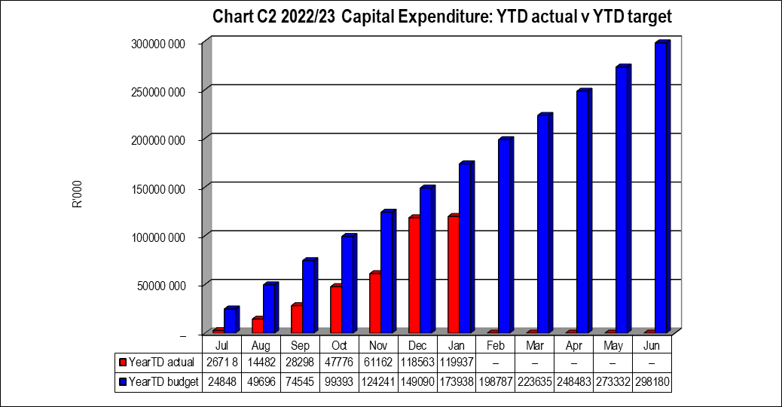

**Expenditure on Repairs and Maintenance by Asset Class**



## 2.7 Municipal Manager’s Quality’s Certificate

Quality Certificate

I, Gamakulu Ma’art Sineke, the Municipal Manager of Harry Gwala District Municipality, hereby certify that-

* The monthly budget statement

For the month of January 2023 has been prepared in accordance with the Municipal Finance Management Act and regulations made under that Act.

Print name: Gamakulu Ma’art Sineke

Municipal Manager of: Harry Gwala District Municipality

Signed____________________

Date______________________